US_Accident ERD Diagram

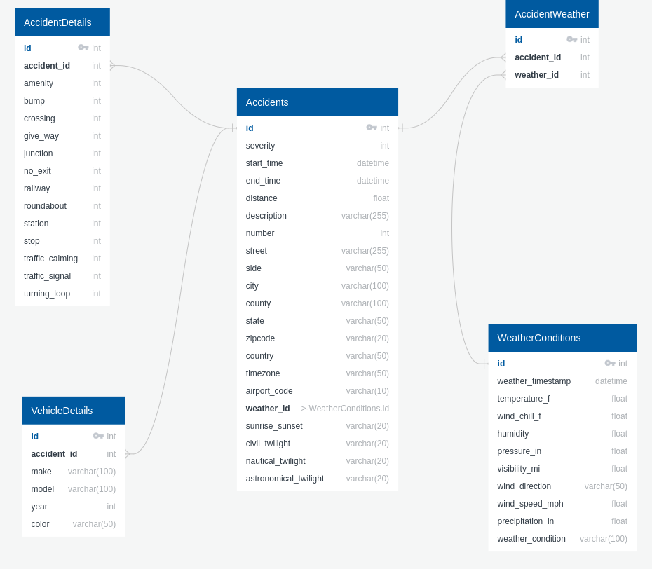

# Diagram Documentation

## Accidents

|  |  |  |  |  |
| --- | --- | --- | --- | --- |
| Field | Description | Type | Default | Other |
| id |  | int |  | PK |
| severity |  | int |  |  |
| start_time |  | datetime |  |  |
| end_time |  | datetime |  |  |
| distance |  | float |  |  |
| description |  | varchar(255) |  |  |
| number |  | int |  |  |
| street |  | varchar(255) |  |  |
| side |  | varchar(50) |  |  |
| city |  | varchar(100) |  |  |
| county |  | varchar(100) |  |  |
| state |  | varchar(50) |  |  |
| zipcode |  | varchar(20) |  |  |
| country |  | varchar(50) |  |  |
| timezone |  | varchar(50) |  |  |
| airport_code |  | varchar(10) |  |  |
| weather_id |  | >-WeatherConditions.id |  | FK |
| sunrise_sunset |  | varchar(20) |  |  |
| civil_twilight |  | varchar(20) |  |  |
| nautical_twilight |  | varchar(20) |  |  |
| astronomical_twilight |  | varchar(20) |  |  |

## WeatherConditions

|  |  |  |  |  |
| --- | --- | --- | --- | --- |
| Field | Description | Type | Default | Other |
| id |  | int |  | PK |
| weather_timestamp |  | datetime |  |  |
| temperature_f |  | float |  |  |
| wind_chill_f |  | float |  |  |
| humidity |  | float |  |  |
| pressure_in |  | float |  |  |
| visibility_mi |  | float |  |  |
| wind_direction |  | varchar(50) |  |  |
| wind_speed_mph |  | float |  |  |
| precipitation_in |  | float |  |  |
| weather_condition |  | varchar(100) |  |  |

## VehicleDetails

|  |  |  |  |  |
| --- | --- | --- | --- | --- |
| Field | Description | Type | Default | Other |
| id |  | int |  | PK |
| accident_id |  |  |  | FK |
| make |  | varchar(100) |  |  |
| model |  | varchar(100) |  |  |
| year |  | int |  |  |
| color |  | varchar(50) |  |  |

## AccidentDetails

|  |  |  |  |  |
| --- | --- | --- | --- | --- |
| Field | Description | Type | Default | Other |
| id |  | int |  | PK |
| accident_id |  |  |  | FK |
| amenity |  | int |  |  |
| bump |  | int |  |  |
| crossing |  | int |  |  |
| give_way |  | int |  |  |
| junction |  | int |  |  |
| no_exit |  | int |  |  |
| railway |  | int |  |  |
| roundabout |  | int |  |  |
| station |  | int |  |  |
| stop |  | int |  |  |
| traffic_calming |  | int |  |  |
| traffic_signal |  | int |  |  |
| turning_loop |  | int |  |  |

## AccidentWeather

|  |  |  |  |  |
| --- | --- | --- | --- | --- |
| Field | Description | Type | Default | Other |
| id |  | int |  | PK |
| accident_id |  |  |  | FK |
| weather_id |  |  |  | FK |